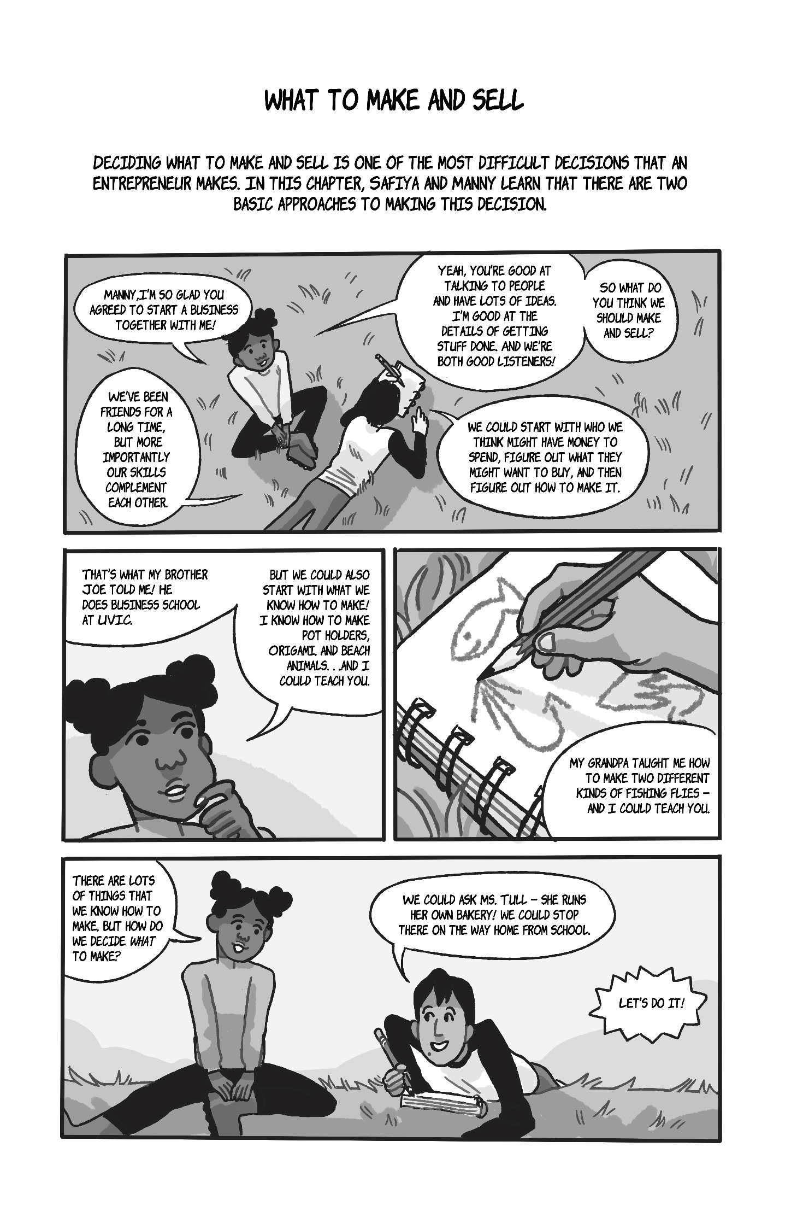
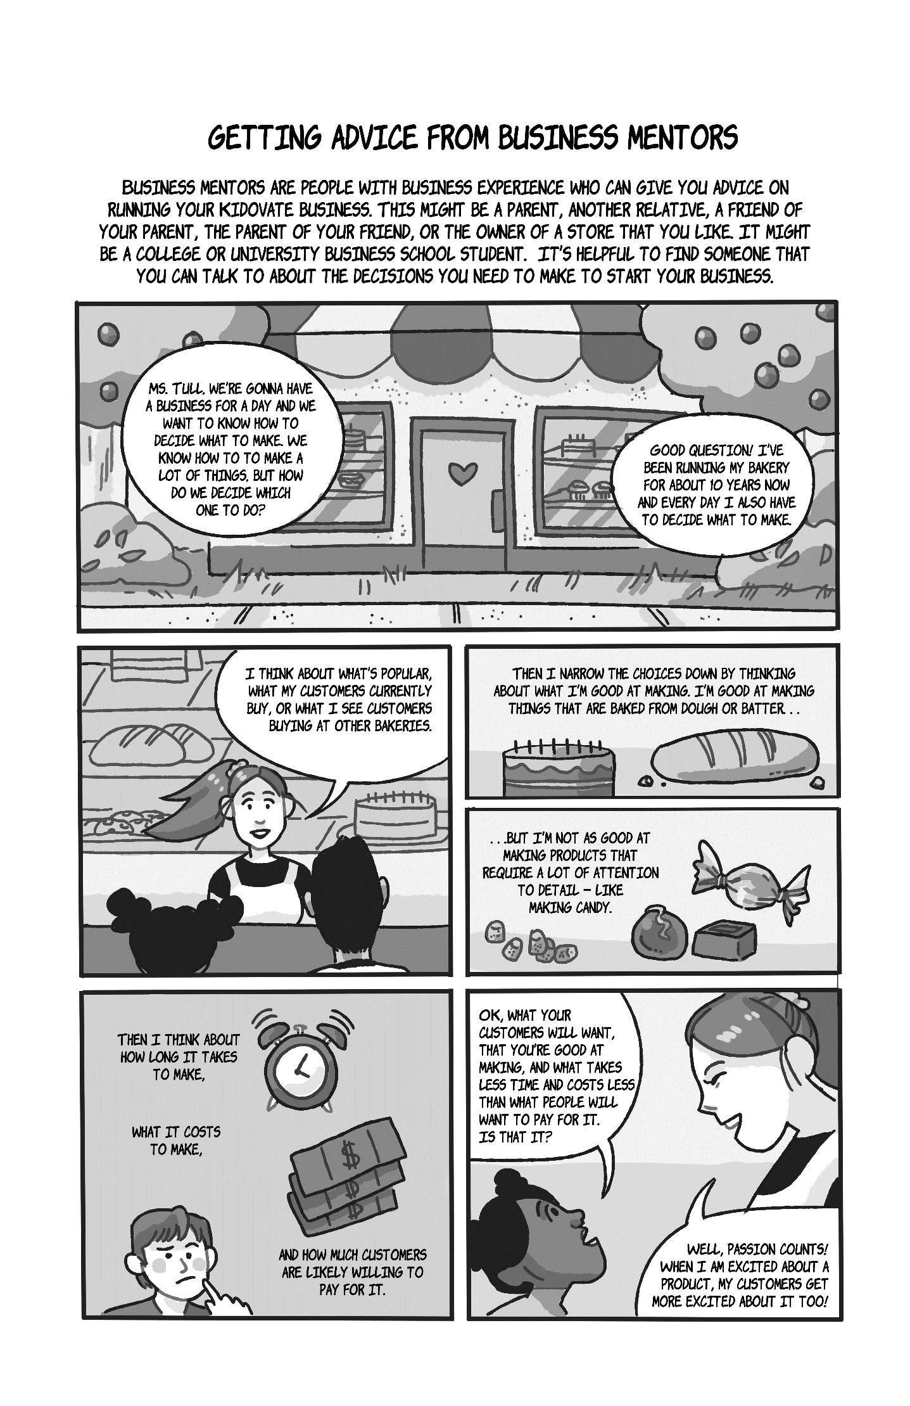
To receive a link to download the rest of the workbook (for free), please email Dr. Brock Smith at the University of Victoria, smithb@uvic.ca.

