

Welcome to Kidovate!

Kidovate is a fun, free, hands-on entrepreneurship initiative for youth like you to learn business skills and make your own money. With Kidovate you will make and sell a product of your own choosing, and we will help you along the way. A key element of Kidovate is corporate social responsibility – the importance of businesses giving back to their local communities. Every Kidovate participant will decide how much of their profit they will donate to what charity or cause. Together we can make a big impact on improving the lives of people and animals.

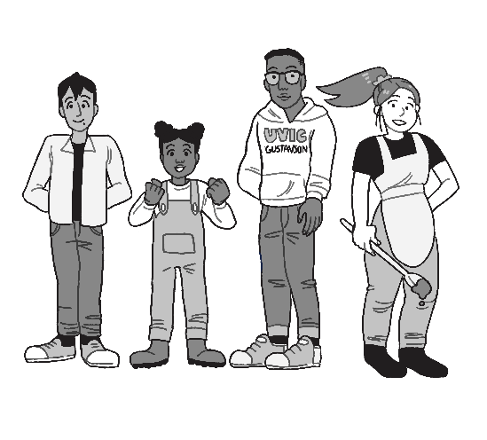

In this workbook, you will meet two young entrepreneurs, Safiya and Manny, who want to make and sell something at a Kidovate market. Each short chapter of the book examines a key decision that Safiya and Manny need to make to start their Kidovate business. You should not read the workbook all at once. You might read one section (1 to 4 pages) per night, or a few sections per week. The first three chapter are found on the Kidovate website. To access the rest of the workbook (free to you) please email Dr. Brock Smith [smithb@uvic.ca](mailto:smithb@uvic.ca) to receive a download link.

You are encouraged to make and sell something at Kidovate marketplace on Saturday April 4th 2020 (10am to 3pm) at The Bay Centre, and possibly other Victoria area malls. You can start preparing any time you want, but spring break is a great time to Kidovate.

© 2019 J Brock Smith & Jessica Ruffalo. This graphic novel is provided for participants in the Kidovate youth entrepreneurship initiative. No other use of the content, cartoons, or characters is permitted without written consent of Dr. Brock Smith of the Gustavson School of Business at the University of Victoria.

